Automating Employee Data

1. Problem Statement

In many organizations, employee data management is handled manually or through semi-automated processes, leading to errors, duplication, and inefficiencies. Tasks such as employee onboarding, updating personal details, tracking roles, and maintaining records often consume significant time and are prone to inconsistencies. Lack of automation also makes it difficult to ensure data accuracy, timely updates, and proper record management. Therefore, there is a need for an automated system that can streamline employee data handling, reduce manual intervention, and improve overall efficiency.

2. Objective

The main objective of this project is to develop an automated system for managing employee data efficiently and accurately. The system aims to reduce manual effort by automating processes such as employee record creation, updates, and validation. It ensures consistency and reliability of data while improving accessibility and reducing errors. Additionally, the project focuses on enhancing workflow efficiency by integrating automated triggers and validations, enabling organizations to manage employee information in a more structured and scalable manner.

3. Skills Required
- Basic knowledge of database management (MySQL or similar)
- Understanding of backend technologies (PHP / Python / JavaScript)
- Familiarity with frontend development (HTML, CSS, JavaScript)
- Knowledge of CRUD operations (Create, Read, Update, Delete)
- Basic automation concepts and workflows
- Problem-solving and debugging skills
- Optional: Knowledge of platforms like ServiceNow

4. Task Initiation
Step 1: Requirement Analysis
Identify what employee data needs to be managed (ID, name, role, salary, etc.)
Define automation requirements (auto ID generation, validation rules)

Step 2: Create records in the Sheet

- Open google sheet

- Name the fields as name,email,department manager and manager’s email
- Enter some records
- Save the sheet as: employee data
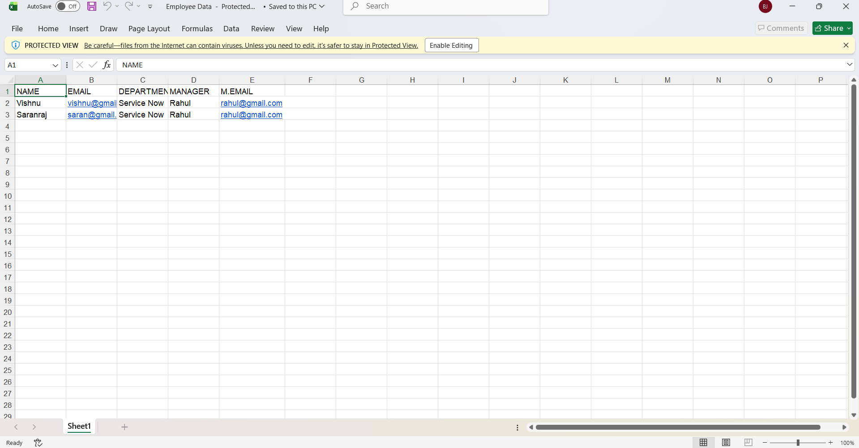

- Download the file as .xlsx , .csv (or) .xml file

Step 3: Import data
- Open service now.
- Click on All >> search for import sets

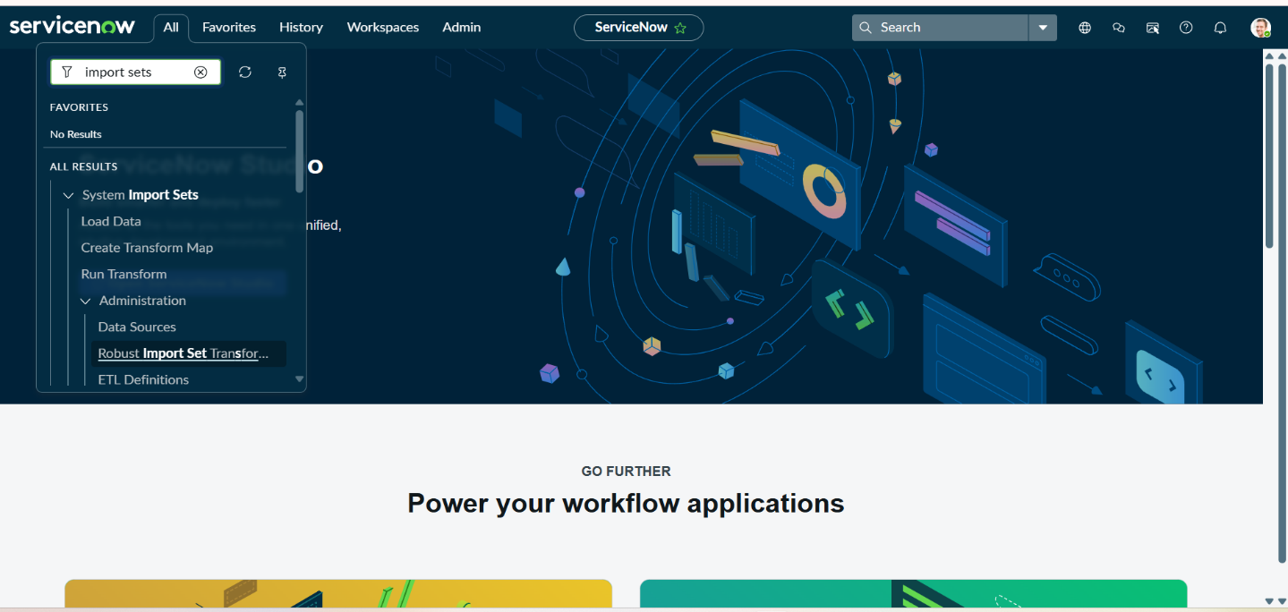
- Select load data under system import sets
- select create table

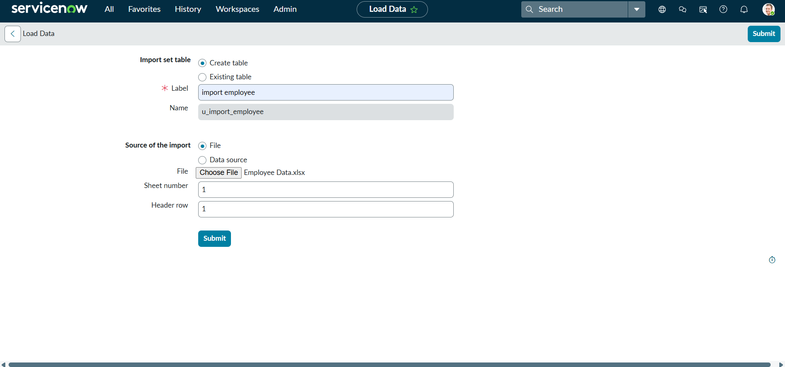
- Give the the import set table name as: import employee
- Choose the file which we created in the XL sheet.
- The data is imported,click on personalized list
- Add fields to the form
Step 4: Create transform map

- Open service now.
- Click on All >> search for import set
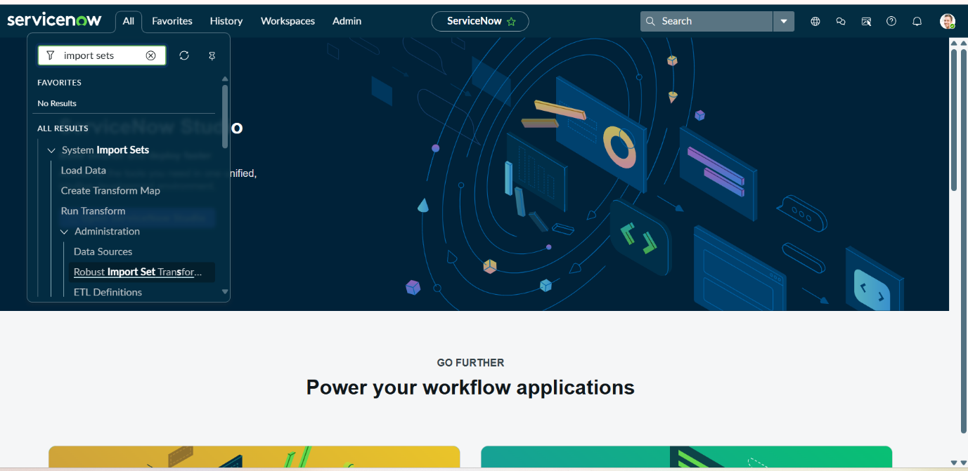
- Select create transform map under import sets
- Click on new
- Fill the following details to create a new transform map
- Give name as: Employee data transform
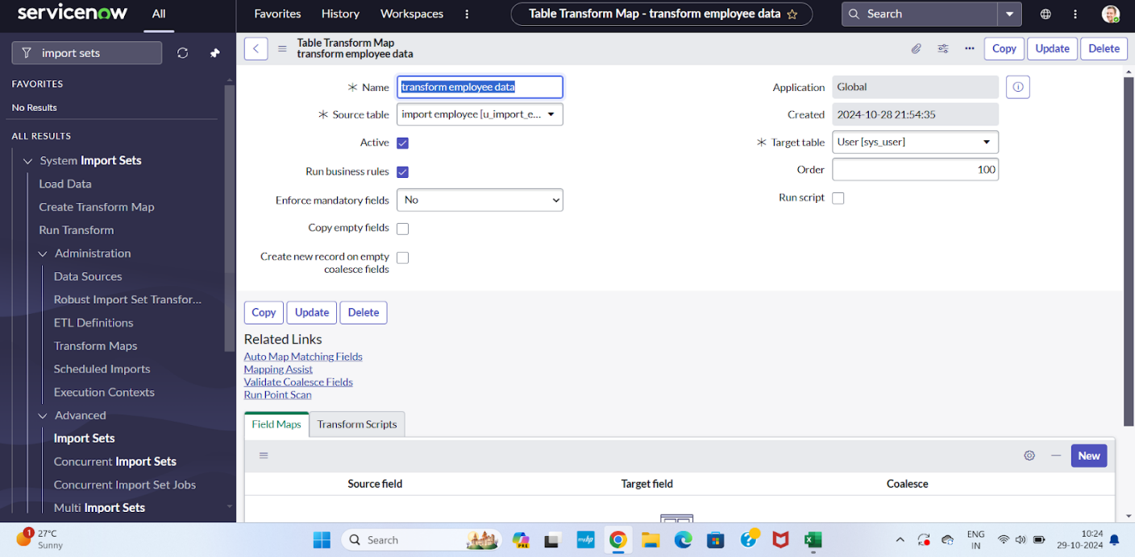
- Select source table: import employee data
- Select target table: user[sys_user]
- Save the form.

Step 5: Match the fields using mapping assist
- Scrolled down the created transform map form
- Click on auto matching fields
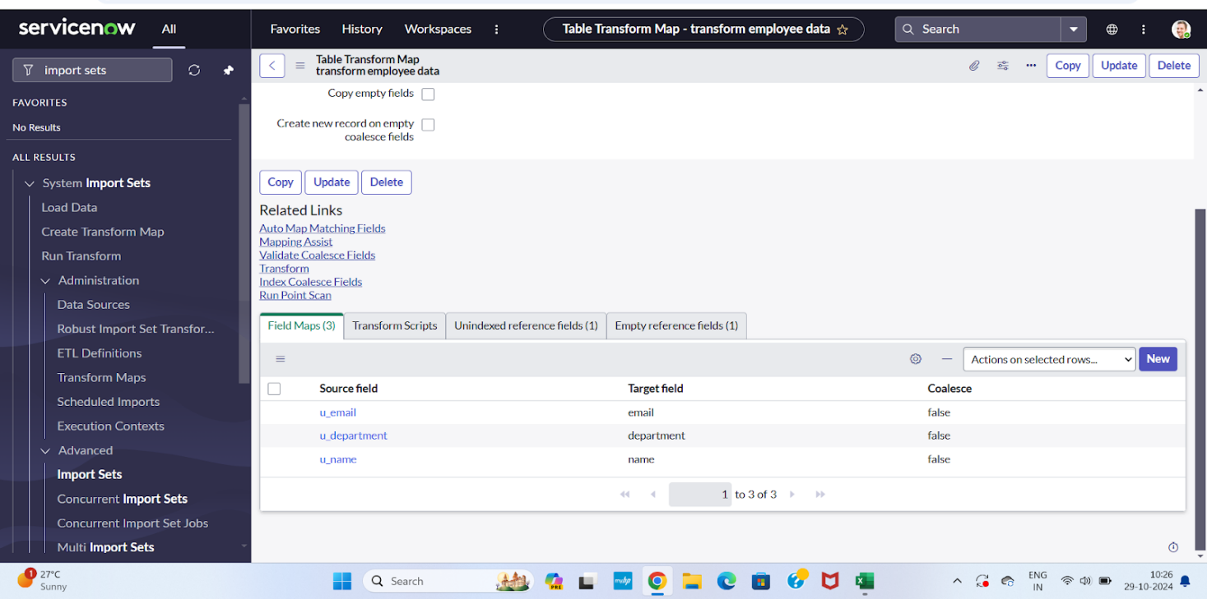
- Then in the mapping fields some fields are matched

- Using mapping assist map the manager field.
- Select the fields which you are mapping in the staging table and target table
- Select manager in source table and add
- Select manager field in target table
- Click on the save button.

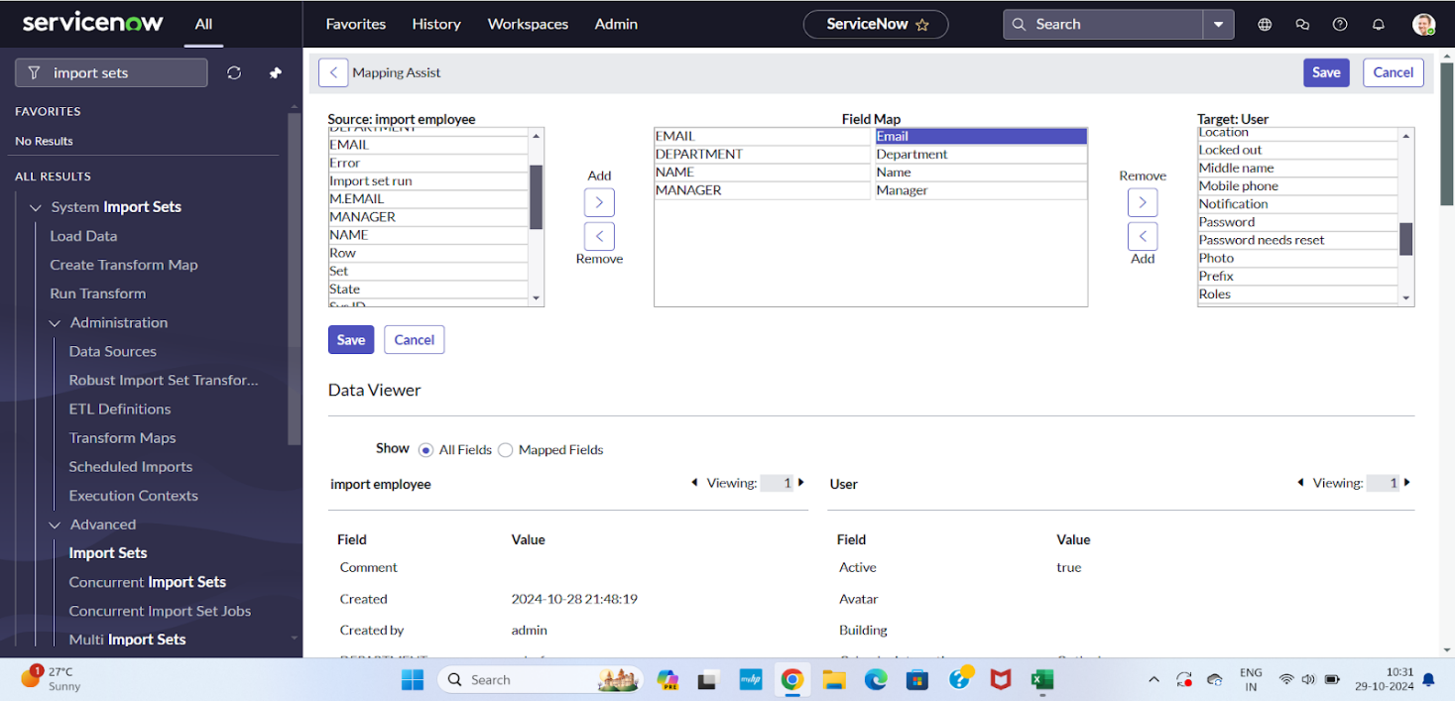

Step 6 : Transform the Data

- Click on transform in the related links.
- Click on transform.
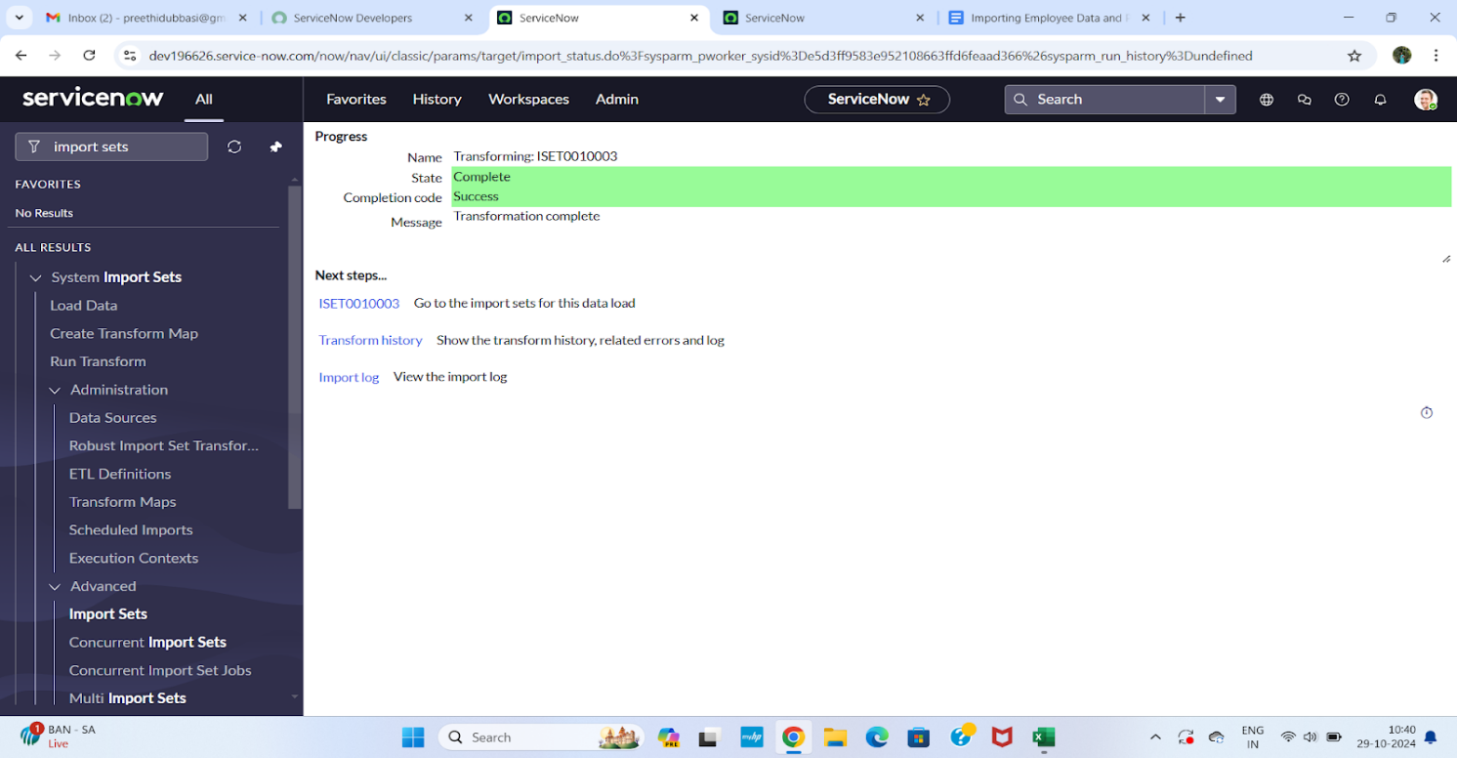

- Data's transform state is completed.
- Click on ISET0010003 under next steps
- Two rows are inserted.

Dot walking
Dot Walking is a method in ServiceNow used to retrieve related field data from a referenced record without opening that record. It allows you to access fields from another table through a reference field using a dot notation (Reference_Field.Field_Name).
In this project, dot walking is used on the Incident form to display information such as Assigned To → Department, Assigned To → Email, and Assigned To → Manager directly from the User table. This eliminates duplicate data storage and ensures real-time visibility of related information, improving efficiency and data accuracy.

Display department to the assigned to user

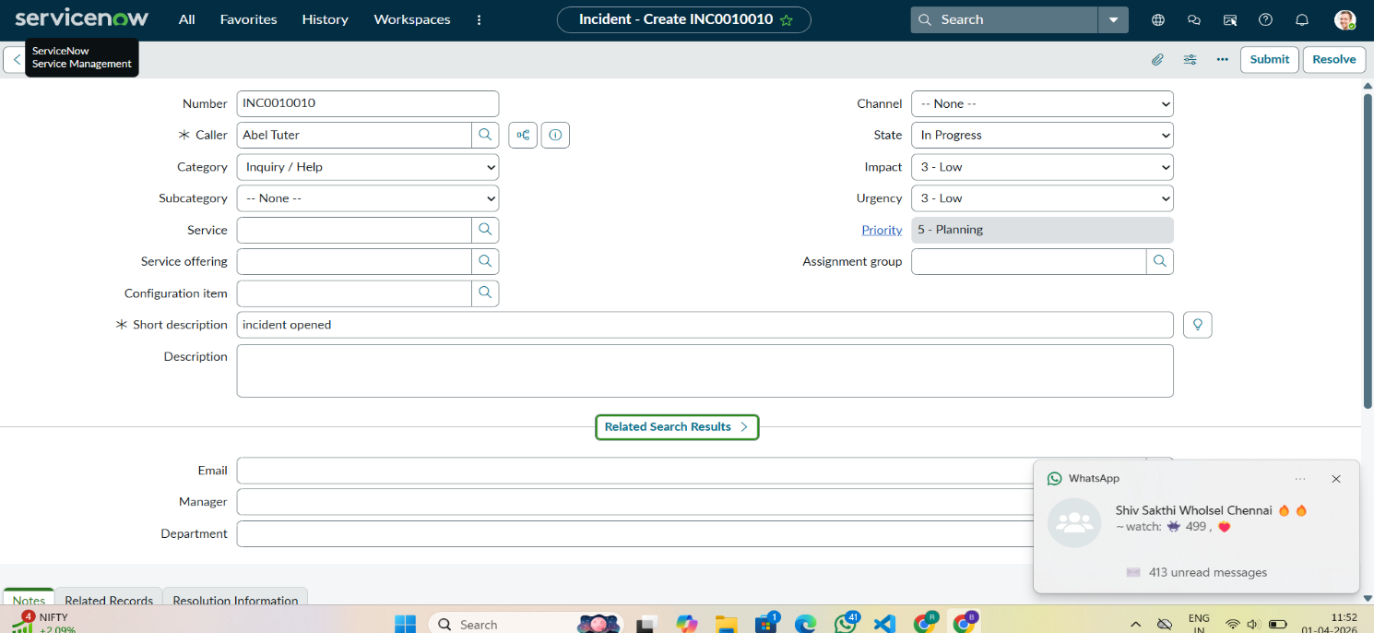
- Open service now.
- Click on All >> incident
- Select create new under incidents

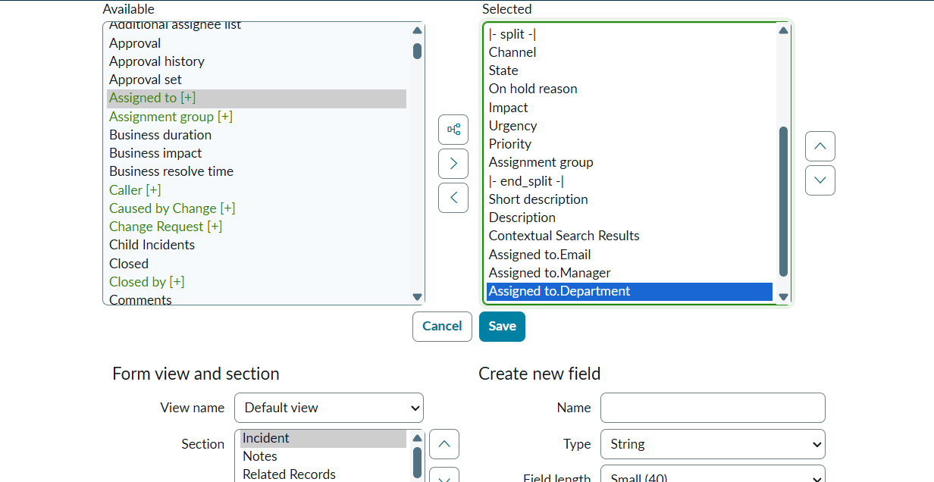

- There is no field like department in the form
- Email and manager fields are not visible
- By using dot walking retrieve the data without opening the record
- Click on context menu go to configure and select form layout
- Select assigned to.department as mentioned below
- Click on save.
10.Add another field assignment.email.
11.Also add assignment.manager field
12.Click on save.


13.Open an incident form
14.Fill the mandatory fields and assigned to just imported user
15. Then department and email field is automatically filled

Dictionary override
Dictionary Override is a feature in ServiceNow that allows you to modify the behavior of a field in a specific extended table without affecting the parent table. Since the Incident table extends the Task table, it inherits all Task fields, including Priority and its default value.
In this project, Dictionary Override is used to change the default value of the Priority field specifically for the Incident table. While the Task table may have a default priority (for example, 4 – Low), the override sets the Incident default to 3 – Moderate. This ensures incidents follow a different default behavior without impacting other tables that extend Task
Make the state to 3-moderate in incident
- Navigate to All → System Definition → Tables.
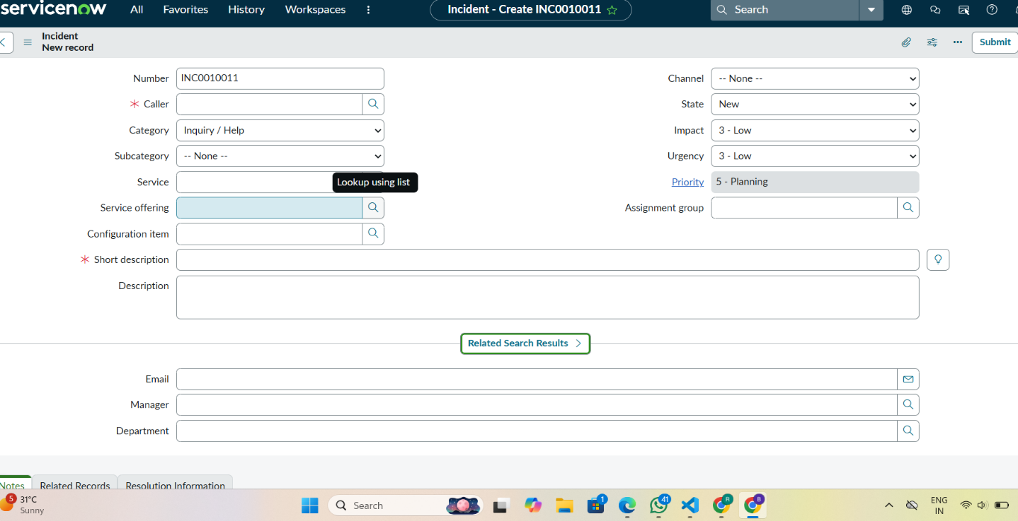

- Either:
- Use the existing Incident table (which extends Task), OR
- Create a new table (e.g., u_incident_table) and set Extends Table = Task.

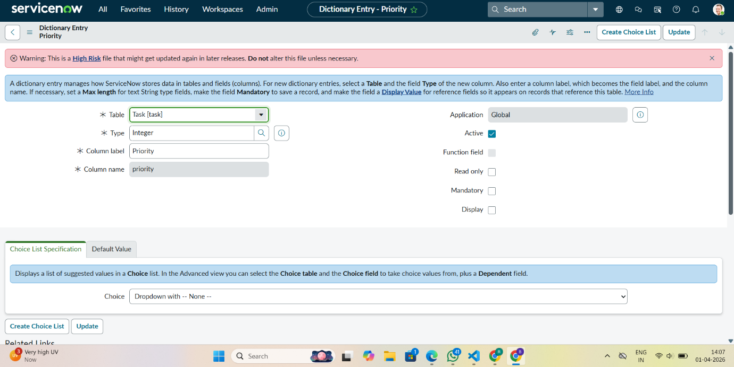

- Open the Incident (or extended) table record.
- Go to the Columns related list and open the Priority field. Notice the default value is inherited from the Task table (e.g., 4 – Low).
- Scroll down and locate the Dictionary Overrides related list.
- Click New under Dictionary Overrides.
- Fill the following details:
- Table: Incident (or your extended table)
- Column name: Priority
- Check Override default value
- Set Default value = 3
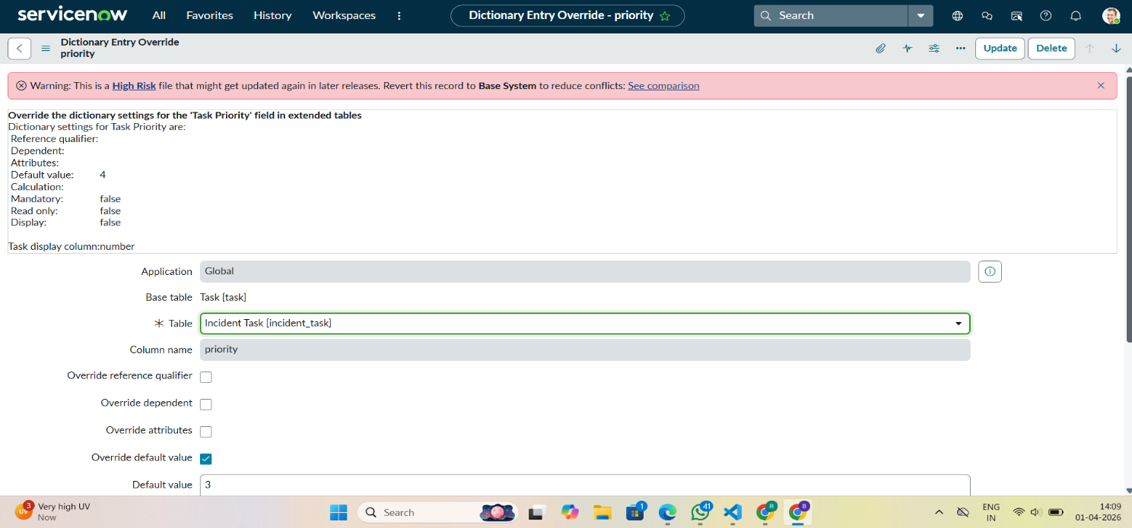
- Click Submit.
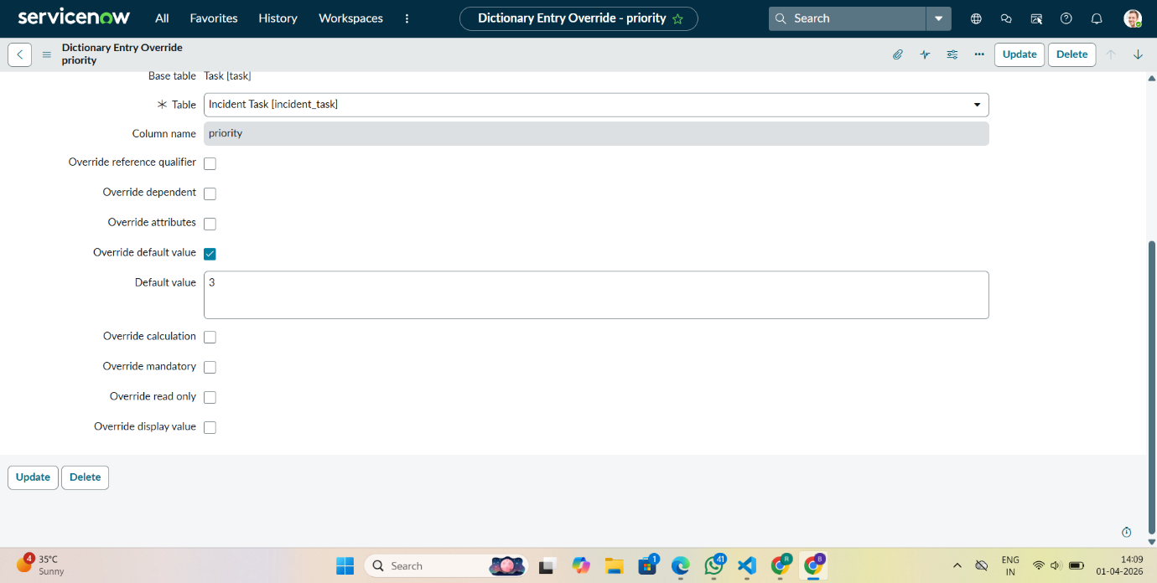
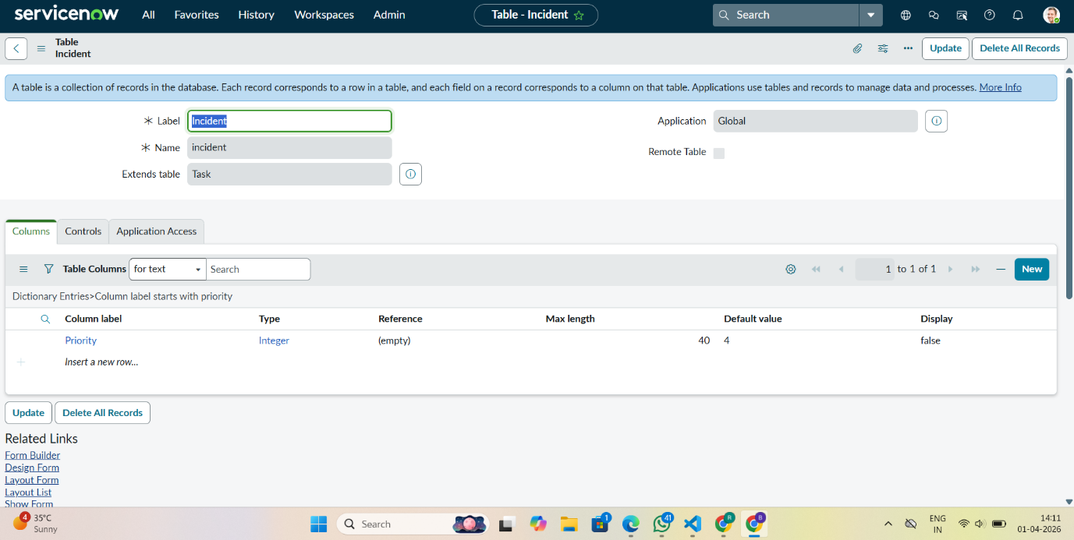

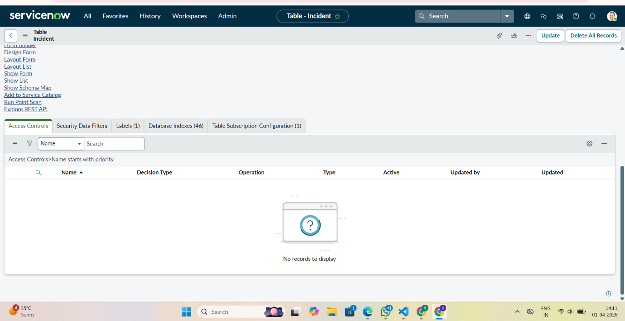

- Open a new Incident record and verify that the Priority now defaults to 3 – Moderate, while the Task table still retains its original default value.

Conclusion
In this scenario, we streamlined incident management in ServiceNow by automating the import of employee data, displaying department manager information directly on incidents, and setting a scustom priority default specifically for incidents. This setup saves time, ensures data accuracy, and gives incident handlers quick access to relevant information, making incident resolution faster and more efficient.

